Purity Test of Lactase after AEXC by PAGE

4. Enzyme Assay of Lactase
4.1 Preparation of an o-NPG-solution
C = 2 mg/mL o-NPG in PM-buffer
PM buffer:
0,01 mol/L NaH₂PO₄
0,09 mol/L Na₂HPO₄
1 mmol/L MgSO₄
adjusted to pH 7,8

4.2 O-NPG-Test

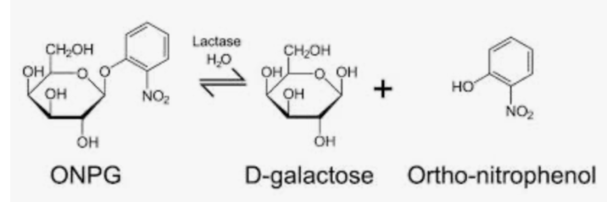

- Pipet in the sample cuvette 50 µL super-natant + 800 µL o-NPG-solution.
- Close the cuvette by a lid and mix the solution by turning the cuvette upside down.
- Put the cuvette in a fotometer and measure absorption at the beginning (t₀) and over
5 min each 30 sec at 410 nm.

- AEXC Purity Evaluation by PAGE
Prepare a 2 M DTT stem solution
Dissolve 0,03 g DTT in 100 μL H₂O_{dest.} by vortexing

Preparation of reducing Laemmli-Buffer
20 μL 2 M DTT-Stammlösung +
2 mL 2x Lämmli-Puffer

Preparation of Electrophoresis Buffer
Each Chamber needs 350 mL 1x TGS:
35 mL 10x TGS + 315 mL H₂O_{dest.}

Preparation of gel cassette
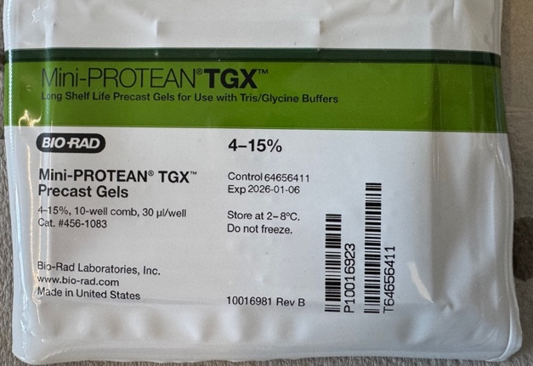

- To open the gel cassette at the botom take away the sticky stripe at the bottom of the gel cassette.
- To open the gel cassette at the top pull out the comb of the gel.

Conducting the PAGE
Run currency: 200 V
Stop PAGE when bromphenolblue has already left the gel for 5 min.

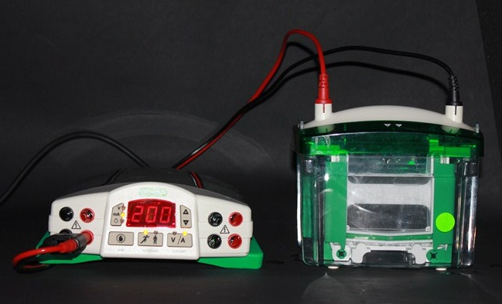

- Quick Test of Lactase in Raw Milk

Material:
- Quantofix Glucose Test Stripes (4/group)
- Valentin buys raw milk

