Purification of Lactase out of an E. coli-Lysate by AEXC

- Lab Tools per Work Group
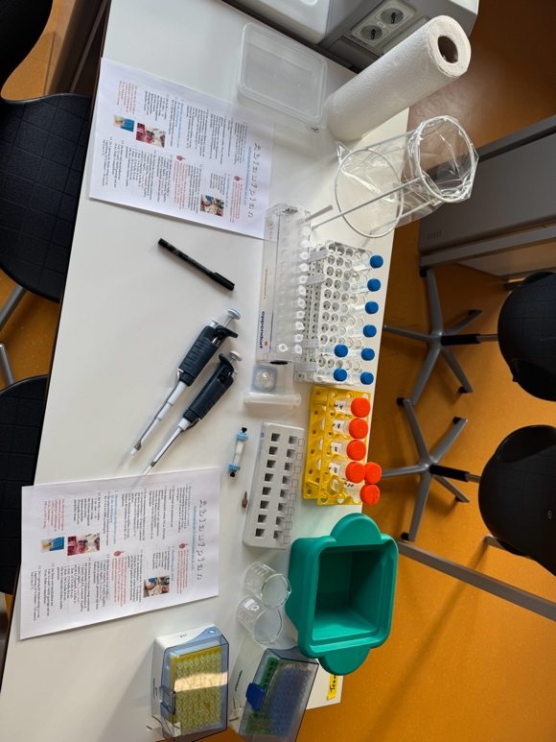

- Production of a particle free cell lysate

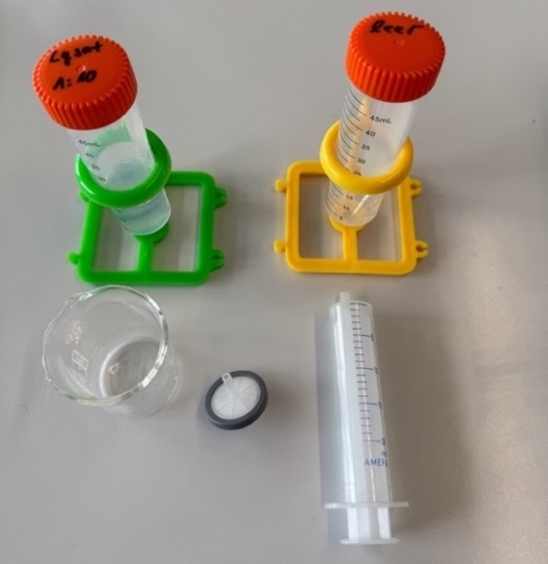
1,1 mL centrifugedE.-coli-lysate
50 mL buffer A
Lab Tools:
Centrifuge (5000 rpm) for 50 mL Falcons (for all groups), syringe (10 mL) + syringe filter (pores size 0,45 μm), 2 Falcons (50 mL), Falcon rack, beaker (50 mL)

- Preparations for AEXC
Preparation of buffer solutions for AEXC
Buffer A: For equilibration and washing the column. Total Volume 2 L for all groups!
17 mmol/L NaH₂PO₄, 8 mmol/L Na₂HPO₄
1 mmol/L MgSO₄, 50 mmol/L NaCl
adjusted to pH 6,5
Buffer B: For Elution of Lactase during AEXC.
Total Volume 1 L for all groups!
17 mmol/L NaH₂PO₄, 8 mmol/L Na₂HPO₄
1 mmol/L MgSO₄, 1,5 mol/L NaCL
adjusted to pH 6,5

Preparation of elution buffer 1:
10 mL 10 % buffer B:
9 mL buffer A + 1 mL buffer B

Preparation of elution buffer 2:
10 mL 25 % buffer B:
7,5 mL buffer A + 2,5 mL buffer B

Preparation of elution buffer 3:
10 mL 100 % buffer B:
Lab Tools for AEXC
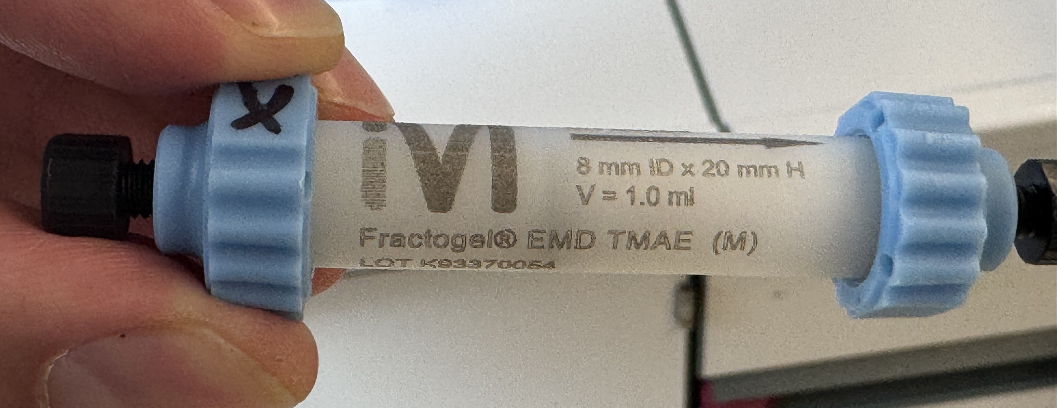

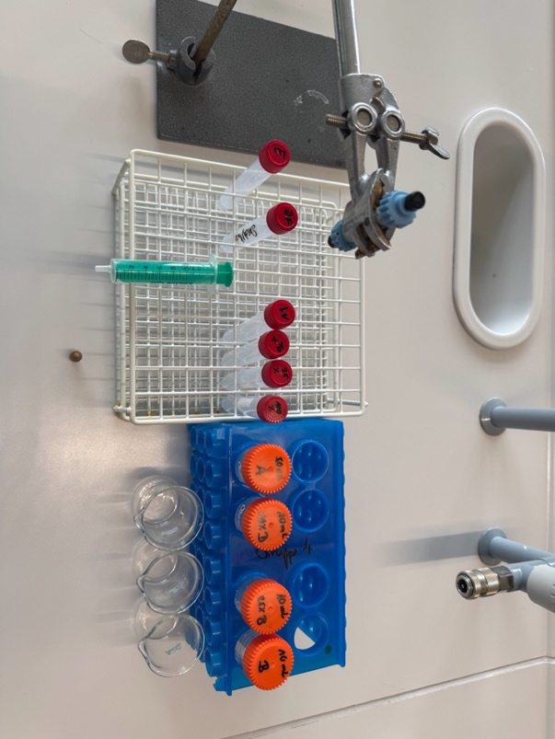
Stand for fixing the column, falcon rack for 6 x 15 mL Falcons, 4 x 50 mL Falcons + rack,
3 beaker (50 mL), column adapter, syringe

Postprocessing AEXC
1. Column cleaning and reuse of column after AEXC
- Step: 5 mL 0,5 M NaOH
(150 mL should be prepared)
- Step: For reequilibration to use the column again immediately wash by 10 mL buffer A.

2. Long time storage of the column at 4 °C
Preparation of 150 mL storage solution
(30 mL Ethanol + 1,3 g NaCl + 120 mL H₂O_{dest.}) for long time column storage in a fridge at 4 °C
5 mL storage solution are filled in each column. Column will be closed at the bottom and top and stored.

