Purification of ß-Galactosidase out of E. coli

1. Production of an E.-coli-Lysate
1.1 The E.-coli-culture in the fermenter is aliquoted in centrifuge tubes of 30 mL each and centrifuged for 10 min at 4000 rpm.

1.2 The supernatant of the tubes is decanted.

1.3 Pipet to the bacteria pellet 750 µL PM-Buffer and resuspend the bacteria by pipeting up and down.
Pipet cell suspension in a 1,5 mL tube.

1.4 Add to resuspended bacteria 350 µL lysozyme solution (c = 20 mg/mL) and mix it by snipping.
Incubate the mixture for 20 min at 37 °C.
To increase the cell lysation rate the mixture is frozen at least for 20 min at -18 °C.
2. Production of a Particle Free E.-coli-Lysate for Purification by Chromatography
2.1 The E.-coli-lysate is centrifuged again for
10 min at 8000 rpm.

2.2 Prepare 11 mL of a  1 : 10 diluted solution  of the E.-coli-lysate  by pipeting 1,1 mL Lysate and  in 9,9 mL Buffer A.  2.3 Use a syringe with a  single use filter on top  (pore size 0,45 µm)  to make the 11 mL of  diluted the E.-coli-lysate  particle free. | 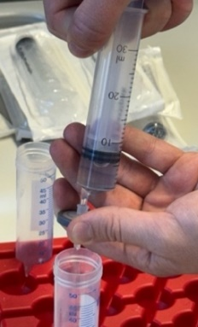
The enzyme activity of the  ß-galactosidase is measured in a quick test by o-NPG-test:  50 µL supernatant +  500 µL o-NPG-solution | 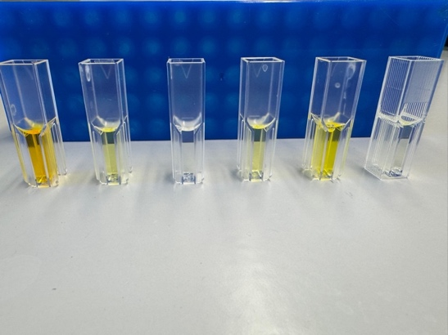
In the following purification by anion exchange chromatography (AEXC) it`s important to avoid air in the column.

3. Procedure of AEXC
3.1 To equilibrate the column 10 mL of buffer A are pressed by a syringe with an adapter on top through the column.  Flow rate of buffer A during equili- bration should be  1 mL/min. | 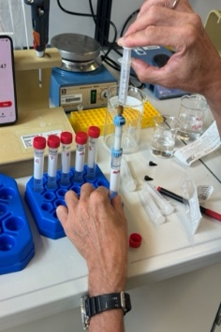

3.2 Loading 10 mL of the particle free, 1 : 10 diluted solution of the E.-coli-lysate on the column is also done with a syringe and a flow rate of 1 mL/min.
The flow through is collected in a Falcon tube.
The flow through of the following washing step of the column (see 3.3) and the fractions of the elution steps (10 %, 25 % und 100 %) are each collected in a Falcon tube and kept on ice till the enzyme activity of ß-galactosidase is measured by photometry.

3.3 The column is washed by 15 mL buffer A
(consisting of 17 mmol/L NaH₂PO₄, 8 mmol/L Na₂HPO₄, 1 mmol/L MgSO₄, 50 mmol/L NaCl
at pH 6,5) and the flow through is collected in a falcon tube.

3.4 The elution of the ß-galactosidase is conducted by increasing the buffer B concentration step by step (consisting of 17 mmol/L NaH₂PO₄,
8 mmol/L Na₂HPO₄, 1 mmol/L MgSO₄,
1,5 mol/L NaCl at pH 6,5) in buffer A.
Each step flow through is collected in a new correspondent signed falcon tube.
1. Step: 6 mL, 10 % buffer B in buffer A,
2. Step: 6 mL, 25 % buffer B in buffer A,
3. Step: 6 mL, 100 % buffer B.

3.5 Cleaning the column after elution is done by 5 mL 0,5 mol/L NaOH.
3.6 Reequilibration of the column is done by
10 mL buffer A.

3.7 Storage of the column is done in 6 mL storage solution (20 % Ethanol + 150 mmol/L NaCl) at 4 °C.

4. Measuring Enzyme Activity
4.1 Preparation of o-NPG-solution
2 mg/mL o-NPG in PM-buffer:
0,01 mol/L NaH₂PO₄
0,09 mol/L Na₂HPO₄
1 mmol/L MgSO₄
at pH 7,8

4.2 Photometry measuring:
Wavelength: 410 nm
Measurement each: 30 sek
No. of Measurements: 5
Reference: 850 µL PM-buffer
Sample: 800 μL o-NPG-solution
+ 50 μL flow through/eluate
Total volume: 850 μL

4.3 Procedure of the Measuring
In a UV transmissible semi micro cuvette are pipeted:
800 µL o-NPG-solution (temperatured for 10 min at 37 °C in a heating block)
After adding 50 µL sample solution flow through or eluate the cuvette is closed by a lid.
The cuvette is turned upside down twice and photometric absorption at 410 nm is started as t₀., and at t₃₀, t₆₀, t₉₀ and t₁₂₀ seconds.

E_{410nm}-values should be in the range of 0,1 till 1,0. If absorption is higher select a dilution factor for your sample by using PM buffer.

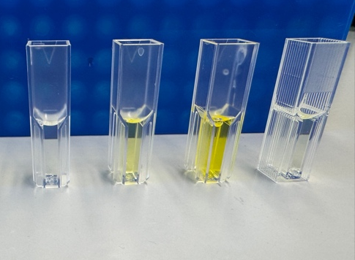
DF
10%
25%
100%

4.4 Save your results
Save your photometric results in the following table.

Transfer your values in the excel sheet for creating a diagram showing ß-galactosidase activities in the flow throughs or eluates.
