Workgroup : Evaluation of the experiment results
DNA Isolation
Jakub Hurt | 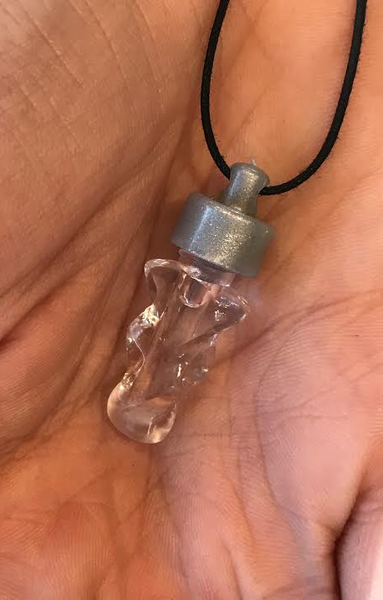  Picture of the necklace | Samet Teke | Picture of the necklace  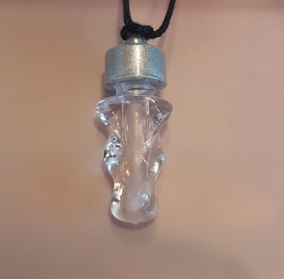

Genetical fingerprint
Who’s the murderer? Murderer was SUSPECT 5
Value table for the Lambda DNA Marker
fragment length [BP] | 9416 | 6557 | 4361 | 2322 | 2027
Log [BP] | 3.97 | 3.82 | 3.64 | 3.37 | 3.31
Migration distance [cm] | 1.1 | 1.4 | 1.6 | 2.1 | 2.4

Picture of your electrophoresis gel:
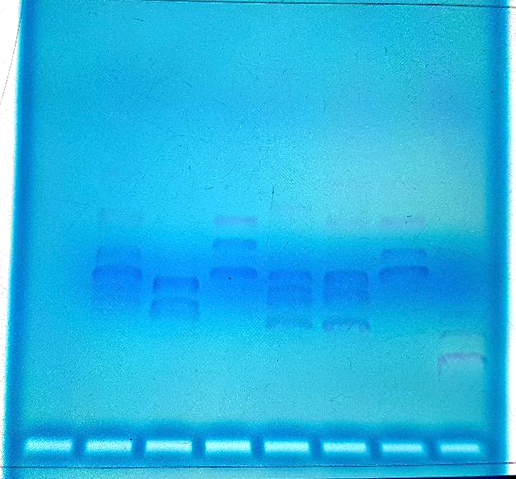

Fragment lengths of the suspect
Migration distance [cm] | 2.1 | 2.3 | 2.7 | 3.2
Log [BP] | 3.42 | 3.30 | 3.08 | 2.78
Fragment length [BP] | 2630 | 1995 | 1202 | 603

