Workgroup 15: Evaluation of the experiment results
 | 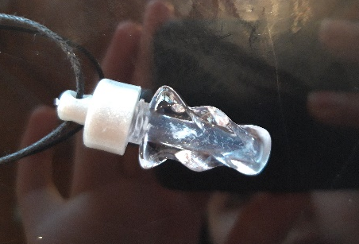 |  | 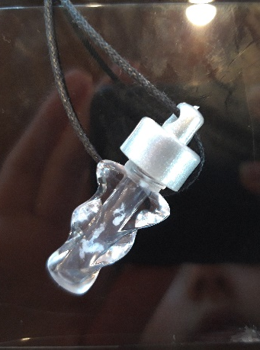
DNA Isolation

Genetical fingerprint
M
CS
S1
Who’s the murderer? Suspect 1

Value table for the Lambda DNA Marker
fragment length [BP] | 9416 | 6557 | 4361 | 2322 | 2027
Log [BP] | 3,974 | 3,817 | 3,640 | 3,376 | 3,307
Migration distance [cm] | 0,75 | 0,9 | 1,1 | 1,5 | 1,8

Fragment lengths of the suspect
Migration distance [cm] | 1,5 | 1,7 | 2,1 | 2,25
Log [BP] | 3,43 | 3,3 | 3,05 | 2,95
Fragment length [BP] | 2715 | 2018 | 1115 | 893

